**HOTEL BOOKINGS PROJECT REPORT**

**Business problem**

City hotels and resort hotels seen high cancellation rates results in fewer revenues and less than ideal hotel room use goal is to increase their efficiency in generating revenue with proper business solution.

**Assumptions**

1. No unusual occurrences between 2015 and 2017 will have a substantial impact on the data used.

2. The information is still current and can be used to analyze a hotel's possible plans in an efficient manner.

3. There are no unanticipated negatives to the hotel employing any advised technique.

4. The hotels are not currently using any of the suggested solutions.

5. The biggest factor affecting the effectiveness of earning income is booking cancellations.

6. Cancellations result in vacant rooms for the booked length of time.

7. Clients make hotel reservations the same year they make cancellations.

**Research Question**

1. What are the variables that affect hotel reservation cancellations?

2. How can we make hotel reservations cancellations better?

3. How will hotels be assisted in making pricing and promotional decisions?

**Hypothesis**

1. More cancellations occur when prices are higher.

2. When there is a longer waiting list, customers tend to cancel more frequently.

3. The majority of clients are coming from offline travel agents to make their reservations.

**Findings**

**.**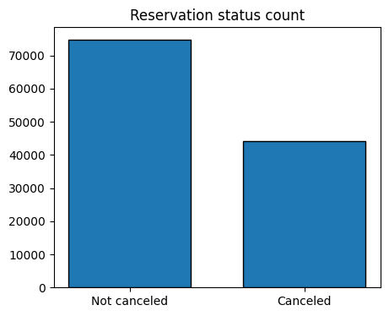

There are significant no of cancellations which are affecting hotel revenue.

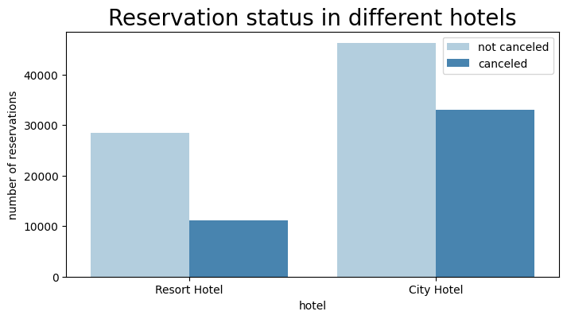

In comparison with resort hotel city hotels have more bookings it may be possible that resort hotels are more costlier than city hotels.

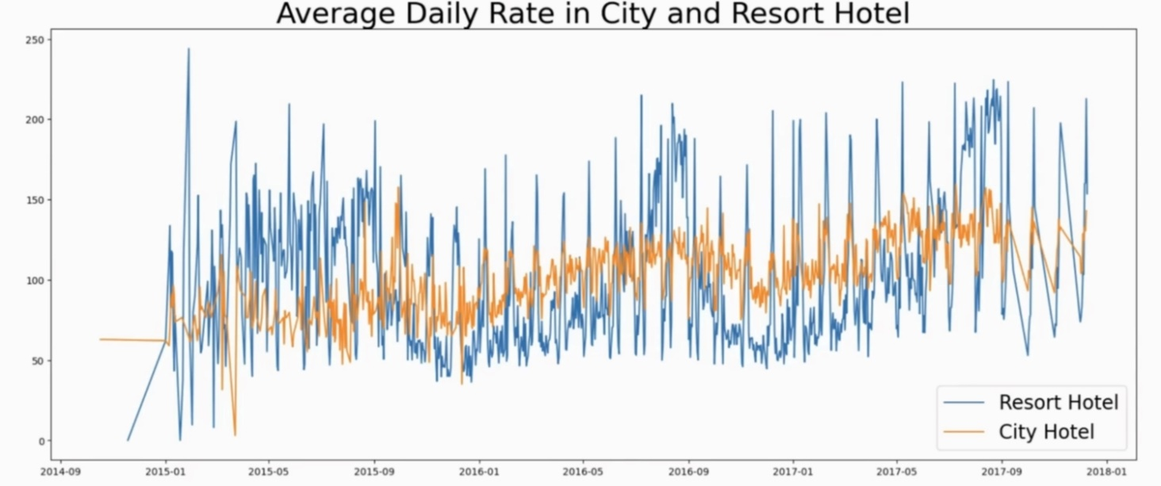

Graph shows on certain days average daily rate for a city hotel is less than a resort hotel and on other days , it is observed that on weekends and holidays rise in resort hotel rates.

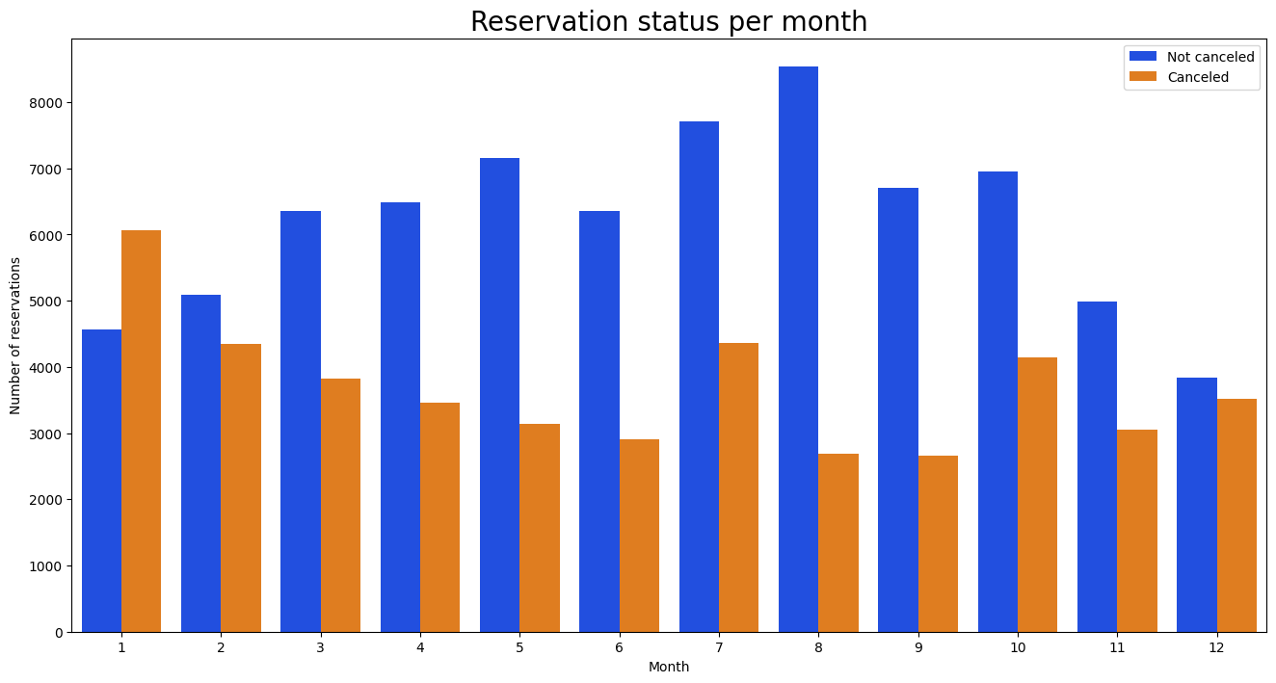

It is observed that January month has most cancelled reservations

and august month has more bookings.

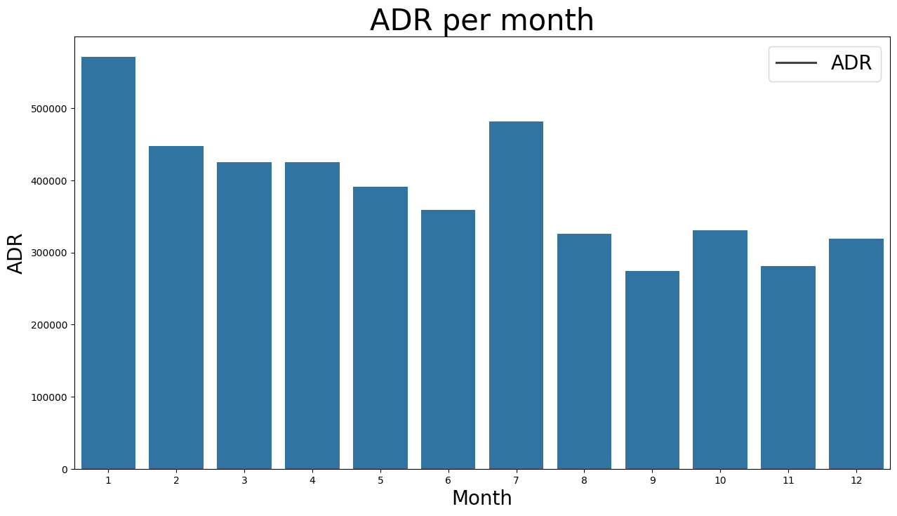

This bar graph demonstrates that cancellations are most common when prices are greatest and are least common when they are lowest. Therefore, the cost of the accommodation is solely responsible for the cancellation.

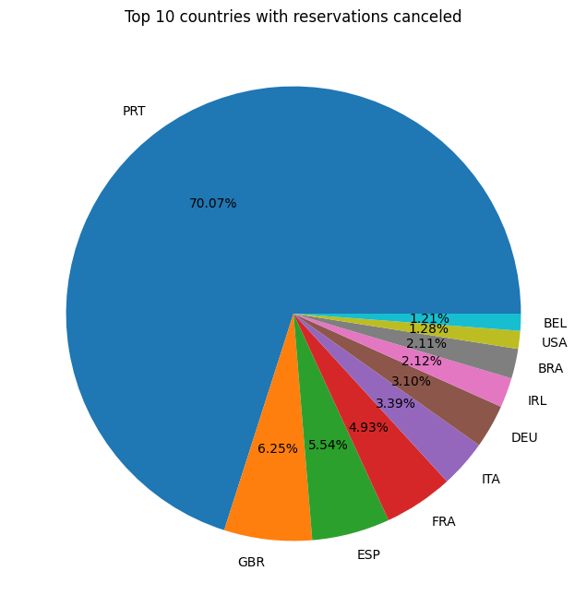

Pie chart shows countries with highest canceled reservations. The top country is Portugal with the highest number of cancellation.

Let's check the area from where guests are visiting the hotels and making reservations. Is it coming from Direct or Groups, Online or Offline Travel Agents? Around 46% of the clients come from online travel agencies, whereas 27% come from groups. Only 4% of clients book hotels directly by visiting them and making reservations.

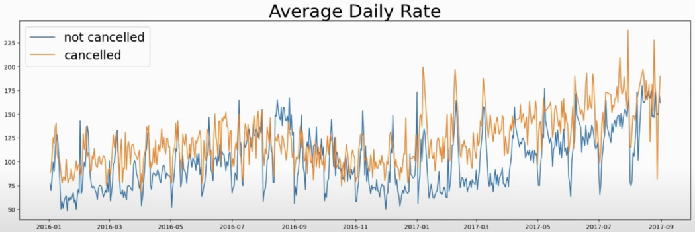

As seen in the graph, reservations are canceled when the average daily rate is higher than when it is not canceled. It clearly proves all the above analysis, that the higher price leads to higher cancellation.

**Suggestions**

1. Cancellation rates rise as the price does. In order to prevent cancellations of reservations, hotels could work on their pricing strategies and try to lower the rates for specific hotels based on locations. They can also provide some discounts to the consumers.

2. As the ratio of the cancellation and not cancellation of the resort hotel is higher in the resort hotel than the city hotels. So the hotels should provide a reasonable discount on the room prices on weekends or on holidays.

3. In the month of January, hotels can start campaigns or marketing with a reasonable amount to increase their revenue as the cancellation is the highest in this month.

4. They can also increase the quality of their hotels and their services mainly in Portugal to reduce the cancellation rate.